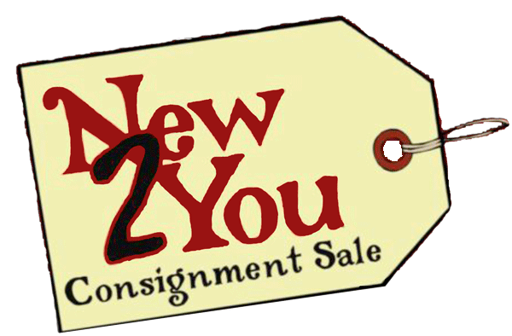
Consigners Contract
Account #
Name:
Address:
City, State, Zip
Home Phone:
Cell Phone:
Email:

- I agree to accept 50% for the sale of my merchandise. Failure to follow Guidelines will result in a profit percentage reduction.
- NTY will only sort: Children’s Clothes, Baby Items, Purses over $15, Shoes over $15, Jewelry over $15. Your responsible for finding you unsorted items on Pick Up Date if you want these items back.

- I will pick up my merchandise & check on
THURSDAY, MAY 27TH FROM 1:00 – 6:00
- Merchandise not picked up on this date & time will become the property of New to You and your check will be mailed to you.

- NTY is not responsible for lost or damaged merchandise. A $5.00 fee is deducted for processing.
Consignors Signature…You have read this contract and agree to its terms.
NTY Use Only

Items are priced by:
NTY_____ Consignor_____ Both_____

Items can go on:
Sale_____ No Sale _____ Some _____
*must have Red Dot and Form in order to guarantee Red Dot!

Items will be picked up:
Yes_____ No_____ Other _____

% _____ (if all items are done correctly 50%)
Otherwise 30% - 40%

Date:_______
Staff Initials ________

Children’s Clothes |  | Toys
Adult Clothes |  | Baby Items
Maternity Clothes |  | Furniture
Shoes |  | Books
CD’s & DVD’s |  | Household
Accessories |  | Electronics
Purses |  | Jewelry
 |  | Total Items

Specific Items that MUST HAVE a Certain Price
 | Item Description | Profit  Price Wanted | Sell  Price | Red Dot  No Discount
1
2
3
4
5

